OPTIMUS

EPSA TEAM

BUSINESS PLAN

Date

FS ATA

Contact information

Parler de :

Sales and Marketing

Operations

Human Resources

Finance

Information & Communication Technologies (ICT)

Information Management

SUMMARY

I. Executive Summary 3

II. OPPORTUNITY 4

II. 1. Problem 4

II.2. Solution 4

III. MARKET ANALYSIS SUMMARY 6

III. 1. Market Status 6

III. 2. Our position 6

III. 3. Competition 6

III. 4. SWOT Analysis 6

IV. EXECUTION 7

IV.1. Marketing and sales 7

IV.2. Operations 8

IV.3. A typical seminar journey 9

IV.4. Milestones and Metrics 10

V. COMPANY 11

V.1. Overview 11

V.2. Team 11

V.3. Legal aspects 11

V.4. The reference car 12

VI. FINANCIAL ASPECTS 13

VI.1. Key assumptions 13

VI.2. Forecast 13

VI.2. Financing 13

VI.3. Statements 13

VI.3.1 Fixed costs 13

VI. 3.2. Variable costs 17

VI. 4. Profit and losses 19

VI. 5. Financial analysis of the company 21

VII.5.1 Input data 21

VI.5.2 Statement of income 21

VI.5.3 Cash flow statement 22

VI.5.4 Balance sheet & and indicators 23

VI.5.5 Graphs 24

VI.6 Financial summary 26

VII. CONCLUSION 27

VIII. APPENDIX 28

X.1 Financial aspects: the low hypothesis 28

X.1.1 Fixed costs 28

X.1.2 Variable costs 28

X.1.3 Profit and losses 28

X.1.4 Fiancial analysis : Input data 30

X.1.5 Statement of income 31

X.1.6 Cash flow statement 31

X.1.7 Balance sheet & indicators 32

# Executive Summary

# OPPORTUNITY

## II. 1. Problem

**Wellbeing at the workplace** rapidly gains importance, as labour laws extend to mental health and as management drifted from Taylorism to fulfillment and motivational approaches. Indeed, the model of a vertical hierarchy is outdated. Tasks are reorganized according to professional skills but also soft skills. **Teamwork** becomes increasingly central in companies daily struggle, and the **teambuilding** market gets to make the most of this trend.

However, many groups (companies, clubs…) do not find affordable and original activities that combine both thinking processes, team decision taking and breathtaking sports. Most teambuilding seminars consist in trips to distant sunny destination with motivational conferences and holidays-like activities. Others focus only on extreme sports, or outdoor activities. People have very varied tastes; therefore, it often is hard to **unify a group** through only one seminar and to entertain all.

## II.2. Solution

Optimus offers a **disruptive innovation** in this field as our seminars provide great **team awareness** and **sense of belonging** to participants, even if they do not share or achieve the same goals in their daily life.

We target companies who are looking for a new kind of experience for their employees, which will efficiently affect their productivity at work. Indeed, during one of our seminars, participants are immersed in an often unfamiliar but intriguing and fascinating environment allowing them to reveal skills they do not usually use.

The automotive sports, as well as the functioning of the vehicles, arouses curiosity. In a **Formula Student type car**, even though most of the mechanics are visible, the concepts and key developments rarely are. Our **unique** vehicle allows **modular** conception, extreme **flexibility** and simplified **compatibility**, which no other car can bring. The approach of the engineer, of the innovator, is peculiar to many people while it still is rooted in each human mind. Therefore, a seminar with the Optimus team gathers varied people around the fascination of **technology** and the enthusiasm of **teamwork**.

What if you are not a car enthusiast and/or you do not fancy driving? Do not worry, our offer includes **diverse activities** that trigger your creative sense, your revolutionary ideas, allowing you to fully enjoy yourself and take significant part in the workshops. **Competition** with other groups and the rivalry between sections and companies motivates the participants to make the most of their efforts.

Moreover, the kind of activities organized brings **positive exposure** to more reserved or modest individuals by providing the opportunity to shine in brand-new situations, resulting in **higher self-esteem** and **self-confidence** in their upcoming professional life.

In short, companies send us employees; we give them back a team.

The chart below highlights the main benefits for the employees of our clients, and therefore, the reasons why they should choose our offer.

Pentagon of success?

# MARKET ANALYSIS SUMMARY

## III. 1. Market Status

## III. 2. Our position

Our focus will be on the French market and we will target all-sized companies wishing to enhance their team spirit through automotive-based entertainment.

## III. 3. Competition

## III. 4. SWOT Analysis

# EXECUTION

## IV.1. Marketing and sales

The first steps in order to launch our business and start our activity will be to birth and raise our **brand awareness**. For this purpose, we will make the most of our several spheres of knowledge. We will use our **broad school network**, as well as our **professional network** and **private sphere** in order to gain renown and appeal to our first potential clients.

In parallel, we will intensely use varied **online** communication networks:

* Linked-in: allows companies to catch professionals’ attention with very efficient and dynamic tools, focused on professionalism and corporations’ benefits
* Instagram: post pictures of our seminars, the performances of the ephemeral cars…, in order to attract young working populations
* Facebook: easy way to follow the news on our company. Facebook is also an easy-to-use tool to organize public events and to quickly gain visibility
* YouTube: show in well-edited videos seminars summaries, reference car advertising, new concepts/activities…
* Twitter: give real-time news, updates on our events. It is also a way for our clients to provide feedback about their experience during our seminars and advertise our service

**Regular posts** on these varied social networks will help us establish strong support from our followers, increasing our brand awareness and benefit from free advertising.

We plan to **film the seminars** and offer a condensed memory to the participants. The resulting videos will be posted on social networks to broaden our visibility to different spheres. The provision of personalized goodies such as 3D printings of the assembled car is directed toward the same objectives.

Having a **well-developed and enticing website** is one of our main prerequisite. It has the essential role of **converting people who express interest in our seminars into paying customers**. Hence, our website must contain appealing media (seminars videos), key information, and potential benefits for the clients (positive testimonies of previous seminars…).

Our emergence will start with a **testing phase**, during which we will offer seminars to partners of EPSA, our car racing team. This period will help us finalize our workshops, have the first feedbacks and charitable and beneficial comments on the seminar.

To be more attractive during our early stage, we will offer **discounts** to the first wave of clients. They will represent a solid base of clients who will participate in the spread of our work by **word of mouth**. Organizing **special events** and offering discounts during limited periods will regularly help **maintain and enlarge our customer base**.

We will combine **Relationship and transactional marketing strategies** to make our premium clients the main advocates of our product. Offering exclusive activities and other advantages (schedules flexibility…) to our loyal clients will help us enhance our existing relationship with them, as well as to benefit from positive and free advertising.

**Canvassing new clients** is also in our scope. By participating in **car exhibitions** or other related events (with stand, communication kits…), we will progressively build our brand image among many companies and racecar amateurs. Internet marketing could also provide new potential clients by enhancing our exposure to car passionate.

Another way to turn the potential client into a customer will be to offer visits of our garage and overviews of our activities and the car. We will obviously not charge those visits as they offer compelling insight into our enterprise and a great opportunity to connect with a future client.

A possible major expansion of our market could be diverse clubs (men’s clubs…), looking for exclusive activities and increased connection between members.

## IV.2. Operations

We based our business in our office, located in Lyon - France. It is a 36 square meters office, divided in two rooms. It is enough for three computers and for meetings with potential clients or partners. This place hosts our business operations and office work.

We rent a 120 square meters warehouse that we use as an assembly garage. This is the main location for the seminars. It allows us to store all of our tools and components, as well as to set up different workshops for the different units working on the vehicle.

Our business is fully based on the **reference car**, that we assemble ourselves with parts and kits we can find on the market. It represents our biggest investment, associated with the adapted tools and kits supplies.

Moreover, we need office equipment in order to run our business successfully, which includes traditional software and hardware.

## IV.3. A typical seminar journey

The seminar will take place in a warehouse where we store all the parts of the vehicle and will last two days. The size of groups will size approximately from 5 to 15 people. The agenda is organized according to the following steps:

The whole group elaborates a quick specification note, to explain global performances in a qualitative manner. Car experts or adepts will be able to specify quantitative details, but the main purpose here is to focus on qualitative car behavior, such as comfort, acceleration and max speed etc... An animator with technical knowledge (Josselin KIEFEL) will help them make the best-suited choices depending on the spirit they want to induce in their car.

The participants will be split into smaller units to discuss and target one or several of the car’s sub-systems they would like to work on. These units need to interact with each other in order to reach the global expected performance and as a result challenge their teamwork.

We have prepared different options for each system in order to make them experiment the choice of design done by an engineer. For example, they will have the opportunity to choose between different brake discs or springs and dampers. But not only, they will also experiment the choices done for ergonomic and aesthetic aspects (steering wheel, seat, body…).

Eventually, the whole group assembles the car with all the chosen sub-systems. To ease the assembly, and to ensure diverse possibilities, we will buy standard compatible parts and kits.

For the artists within your group, complementary workshops are possible, such as painting the body, to wrap up the customization of your vehicle as your own.

The seminar ends with the driving of the vehicle that has been built during the two days of seminar.

Challenges between companies or between sections bring intensity and competitiveness to the seminar. Those will be based on different factors such as driving performances, general properties, aesthetics, costs…

According to our initial investment, live competition will not be possible before we can buy an additional car, however we will emphasize and expose previous groups’ performances during the seminars, as well as on our social media, to trigger the competitiveness of participants.

To summarize, we can imagine a “conceptual and assembling phase” during the first day and the next morning, and a “competitive driving phase” for the last afternoon

## IV.4. Milestones and Metrics

We defined clear objectives for the development of OPTIMUS’s business. We instituted qualitative and quantitative criteria to describe our progress (milestones) and key metrics to evaluate our performances.

We chose challenging but reachable objectives to first motivate our team and second structure the project. The key milestones are summarized below.

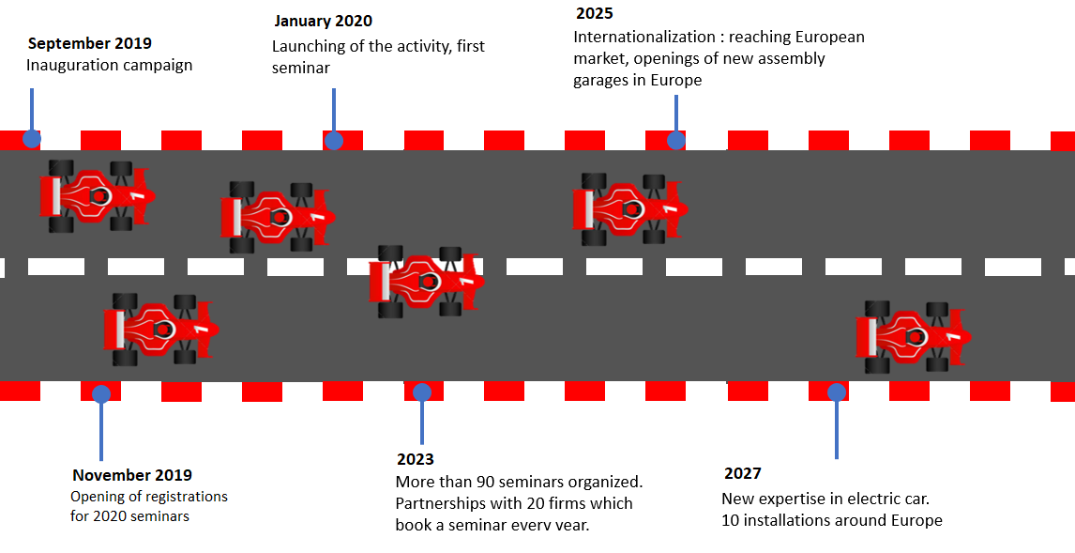

The key metrics that are important for understanding how the business is doing are a combination of client’s feedback and booking requests. We will measure our success based on several criteria: ability to book seminars, need to expand our business to other locations, to invest in additional vehicles, financial growth of Optimus. However, the customers’ feedback (did employees enjoy themselves? was there a noticeable impact on productivity? Etc…) is also an extremely valuable indication of performance, which we can measure and quantify on social networks, participants’ and companies’ feedback...

# COMPANY

## V.1. Overview

Optimus aims to become a reference in the field of team building seminars. We offer Vehicle Assembly and Driving seminars for firms and groups that seek to offer a creative, cohesive and thrilling experience to their members around the design and driving of a formula type vehicle.

The concept emerged at the Rollout of Optimus, during which we commonly realized that many people, even not formula enthusiasts, were very interested in the assembly of the vehicle, what was what for and how it was conceived. Most also were greatly attracted by the driving experience.

## V.2. Team

As a result, we, Charlotte DILLARD, Robin CLAMENS and Josselin KIEFEL, founded Optimus as a start-up in January 2019.We are three students of Ecole Centrale de Lyon (ECL) who united and joined forces in order to succeed in the challenging adventure of entrepreneurship.

Our profiles are complementary, binding management, finance, negotiation, marketing and engineering, while our minds are chock-full of motivation.

|  |  |  |
| --- | --- | --- |
| Charlotte DILLARD | Robin CLAMENS | Josselin KIEFEL |
| Marketing and finance director | Organization and logistics | Engineering  Car mechanics knowledge |
| Rigorous  Creative  Communication  Attention to detail | Meticulous  Well-organized  Synthesis, big picture  Public speaking | Innovative  Expertise  Logical thinking  Problem solving |
| Photo | Photo | Photo |

Photo & description team members and roles

Moreover, we are lucky to have as advisors successful entrepreneurs Patrick SERRAFERO and Jerome DILLARD, as well as several renowned ECL teachers specialized in business administration and car mechanics, who can help us as business owners.

## V.3. Legal aspects

Optimus will be created as a Limited Liability Corporation (equivalent of SARL, “Société à responsabilités limitées in French”). The three members will privately own the company through shares, proportional to the contribution to the capital.

The associates’ liability lies in the financial contribution, investment.

The taxes associated to the operations are corporate taxes. In case of unanimous decision, we can switch to income taxes, notably for financial advantages.

The company can share its profits between investors, employees and new investments after tax payment.

To spread our workload, expand production and take advantage of skills and expertise, the following must be taken into account:

The salary that the company wants to pay must respect the national minimum wage and must be written in the employment contract.

Employees must be legally allowed to work.

Our logo will be submitted through the National Institute of Industrial Property (Institut National de la Propriété Industrielle) in order to trademark it. If our application is accepted, the logo will then be added to the INPI database.

The trademark registration is valid for 10 years in the countries where it is registered. The trademark can be renewed every 10 years for the same period.

## V.4. The reference car

OPTIMUS will be the reference car; it is a Formula Student type vehicle equipped with state-of-the-art technologies and designed for high performance.

# FINANCIAL ASPECTS

## VI.1. Key assumptions

The accurate planning we made here above will permit us to have a precise idea of the financial resources we will need. But inevitably, there is also some uncertainty about sales volume, that is why we based all our predictions on two hypotheses : the high hypothesis – where the company is very successful – and the low hypothesis – where the company has more difficulties to shine at start. All the explanations about our approach will be illustrated by tables from the high hypothesis. Tables from the low hypothesis are included in the appendix, page ?

Obviously, all the costs associated with the launch of the company are the same, regardless of the assumption considered.

## VI.2. Forecast

## VI.2. Financing

## VI.3. Statements

### VI.3.1 Fixed costs

Marketing and communication

We decided to consider the creations of previous companies and to ask around us to set a budget of around €100,000 for the first year, to give us the opportunity to develop and improve our brand image and brand recognition. The following years will have a budget of €50,000, which is consistent for maintaining a good notoriety after the start spike.

We decided in the first year to allocate a large part of our budget to the launch of our brand. the objective is to create expectations among future customers and stand out immediately in a very competitive sector. The rest of the budget should be allocated to various promotional methods, by advertising or by showing the assembled car on race circuits.

Our goal as noted above, is to limit the cost of the department related to our business. On marketing and creating partnerships, we expect to benefit from commercial advantages so as to considerably reduce variable costs, as we will see further.

Real estate

Headquarters

Our office is located in Lyon - France. We rent it every month for €710 (charges included). It is a 26 squares meters office, divided in two rooms. It is enough for two computers and for meetings with potential clients or partners.

Warehouse/Assemblyegarage  
We rent a warehouse which is used as an assembly garage. This is the main place for the seminars. Its surface is 100 squares meters which will permit to store all our tools and to set different workshops for the different part of the vehicle. It represents a cost of €560/month (taxes and charges included).

Insurance

We chose Insurance Pro entrepreneur with maximum guarantees for €8,400:

-Liability (Break of the screen of a computer assigned to repair …)

-Legal protection (Delay of a supplier to deliver the goods essential to our business)

-Local and business property (fire, explosion, glass breakage, water damage, theft …)

-Financial protection (if damage, while electricity-type loads continue to be paid)

-Vehicle

Electricity

We will have €200 annual subscription with EDF, the French electric service company corresponding to 12kWh. We also plan to have a phone and an Internet subscription for our office which costs €85 per month.

#### Wages

Wages are significantly the biggest part of our fixed costs. Here are the different employees we will pay, in addition to the CEO and the marketing director:

* Engineer: Its role is to seek for kits that are more or less easy to assemble on the vehicle. He is an expert on the assemble process, security rules, skill and time requirement for the integration. We employ 1 engineer for the first year, that we pay €34,000 net.
* Commercial: Its role is to sell our innovative concept to potential customers. He is extremely mobile and knows perfectly well the service we propose, and how it will certainly help the client to improve its executives’ productivity and engagement. We employ one commercial for the first year, that we will pay €32,500 net.
* Animator: Its role is to take care of the whole customer’s group during the 3-day seminar. He is able to understand the persons’ will, and propose different solutions to lead them to the vehicle they eventually want to build. He is very sociable and careful. Animators are the basis of our concept, as a teambuilding service, that’s why they represent a large majority of our employees. We will employ one animator for the first year, that we will pay for €20,000 net.

According to the hypothesis considered, wages are increasing in diverse ways, as well as employment policy.

Reference car

We will assemble ourselves the reference car, with parts and kits we will buy on the market. We evaluate this cost at €50,000.

Furniture

We will buy desks, computer hardware, shelves and racks for headquarters (administrative and design department) and warehouse (seminar location). We will also buy a TV on the fifth year, to improve our welcoming ability and the efficiency of meetings.

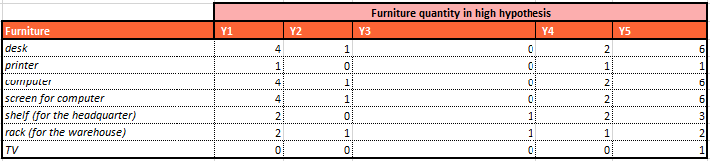

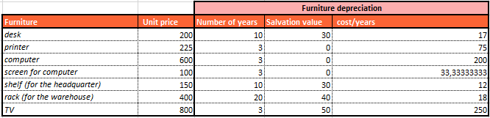

Company car for commercials

As said previously, it is important to have very mobile commercials, because we will need first to meet our clients by ourselves, given our low recognition. We will purchase a company car on the second year for this purpose, and other cars later.

Additional parts and kits

Our concept relies on the various possibilities of vehicle one can build from the reference car. That is why we plan to get a considerable stock of parts and kits that we can set in place and remove easily. Each year this stock will increase, so we will expand our offer. We will start with a €20,000 worth stock.

Toolings

Some toolings will be also necessary for the assembly, such as toolboxes etc… We will assign a tooling budget of €1000 for the first year, and more for the next years so as we can adapt our means to the new kits we will get.

Website

We will charge a professional firm for the development of our website. Its aim is to explain who we are, what is our concept, how to contact us, and to show some pictures and features that will spotlight the benefits of our product for companies, so it is mainly a showcase. Such a development usually represents a €12,000 investment. We will also pay €500 per year for its maintenance.

Accounting

We will charge a professional firm for accounting, as well, for €400 per month. We plan to implement our own accounting service in the future, for more autonomy, but it is not a priority, since wage expense will be far higher than the price of a professional firm.

Brand protection

Register the trademark of VULCANIX

According to the website of the INPI (National Institute of Intellectual Property), the trademark VULCANIX is available. We want to register the trademark because many companies are currently doing business around race cars and it will be an asset for us in the future to have the monopoly on this brand, which also will serve as a trade name. The cost of a trademark registration is €200.

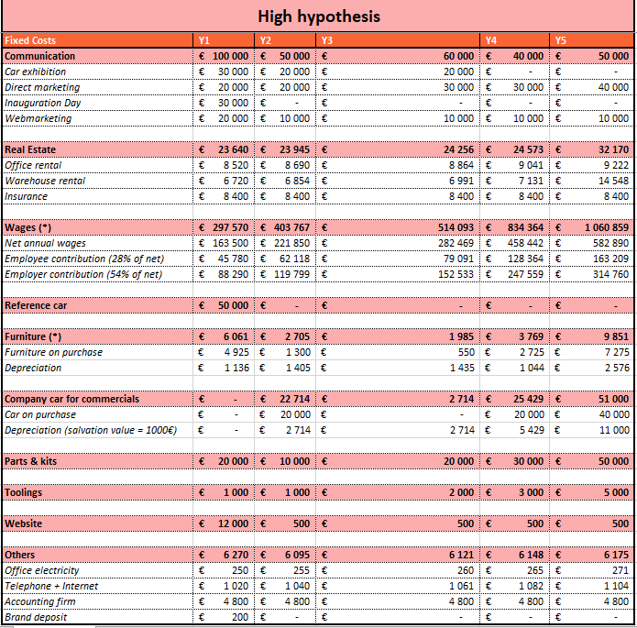

### VI. 3.2. Variable costs

Our variable costs are due to circuit booking + pilote teaching (€1,180 per seminar), delivering people + the car on the circuit (€850 per seminar) and provide rest and food to our customers (€750 per person). We believe that on being a regular client to hotels in the area, we will manage to lower that latter cost at €600 on the fourth year. In order to keep a regular final price growth, and counting on our well-established notoriety at this time, we will increase more significantly the margin we make to compensate the reduction for our clients, because that is not what we want, for now.

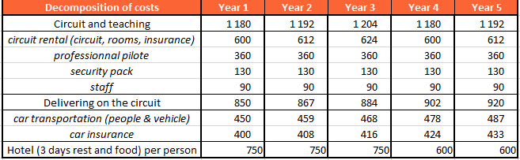

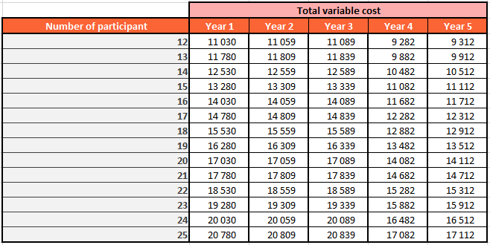

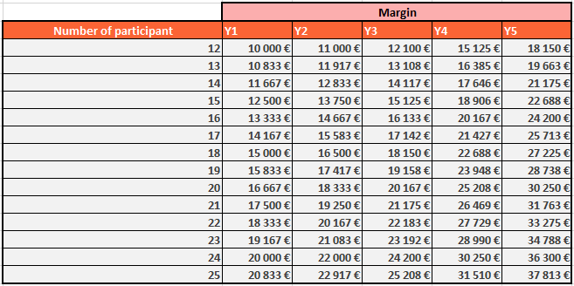

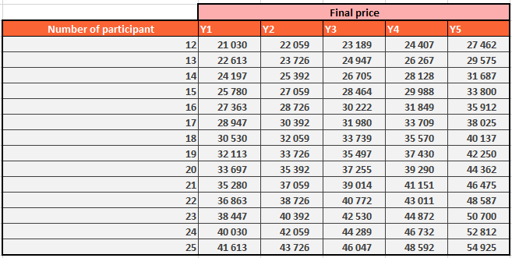

## VI. 4. Profit and losses

Our turnover and expenses highly depends on our sales volume, so we introduced 2 scenarios. In the high hypothesis, it is described here below :

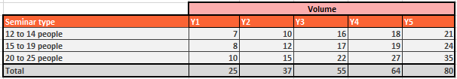

These sales volumes are the very cause that made us adjust our expected expenses such as fixed costs, and financial parameters, to keep being profitable. In the low hypothesis, sales volumes are described on page ?.

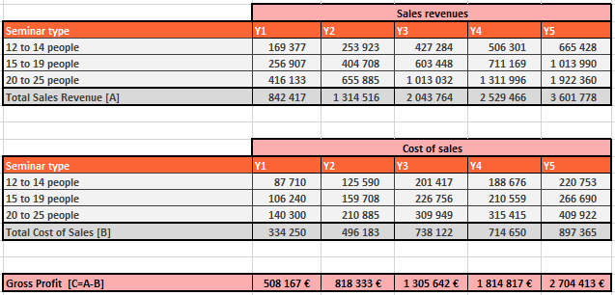

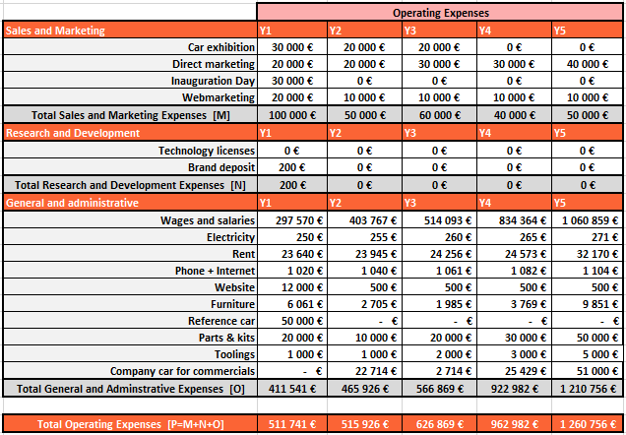

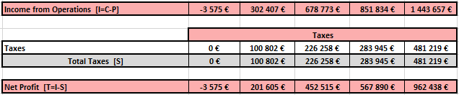

## VI. 5. Financial analysis of the company

### VII.5.1 Input data

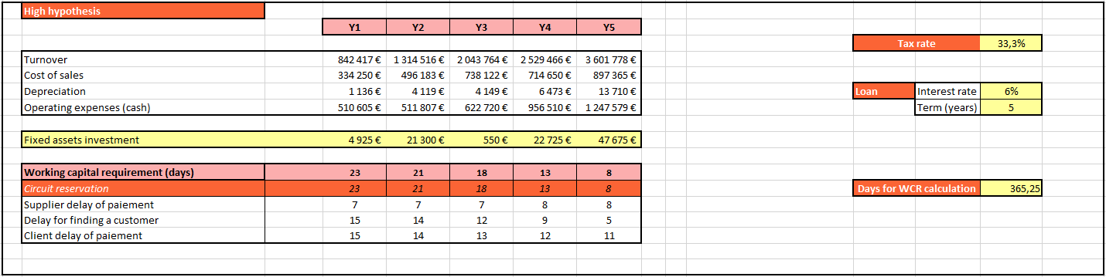For this analysis, we need the information in the table right :

*Figure VII. 8 : Input data*

Over time, we believe that we will manage to reduce the client delay of payment and negotiate a higher supplier delay of payment. We also assume that our success will make it possible to find a client more quickly, 5 days for instance at the 5th year. All these reasons lead to a decreasing working capital requirement (= change in working capital), which is very positive for flexibility and quick reaction to the market.

To launch our company, we will do a large communication campaign and buy a lot of assets and products. All the glorious years in the future rely on our first breakthrough, so to ensure this, the members of the team will bring €110,000 and investors should bring €90,000. In addition, we will make a loan of €75,000, and then the activity will start efficiently.

### VI.5.2 Statement of income

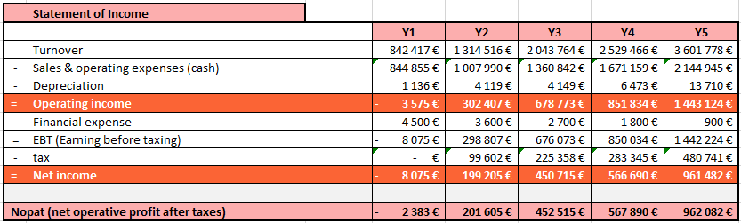In the high case, we have a slightly negative NOPAT on the first year, which become positive on the second year, and keeps growing exponentially:

*Figure VII. 9 : Statement of income*

Therefore, our NOPAT breakeven will happen early in the second year

### VI.5.3 Cash flow statement

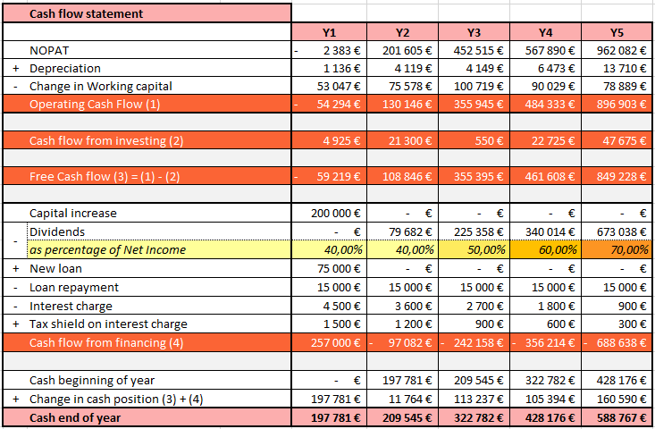

*Figure VII. 10 : Cash flow statement*

We can see that our cash at the end of the year is always positive. We do not expend it during the five first year (although we distribute 70% of our net income as dividends to shareholders like investors) because we plan to get machines and other sites in Europe, thanks to this provision.

### VI.5.4 Balance sheet & and indicators

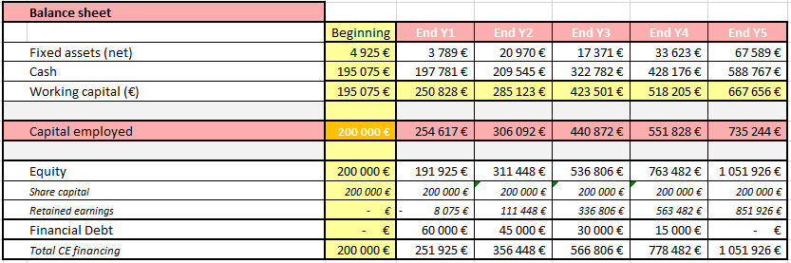

*Figure VII. 11 : Balance sheet*

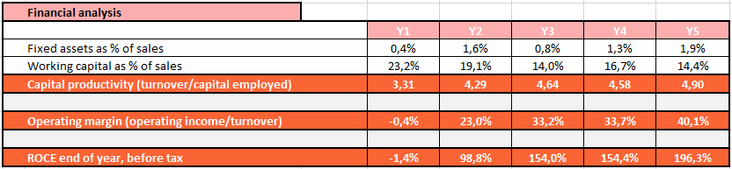

*Figure VII. 12 : Financial analysis*

Thus a financial analysis shows that our capital is well used since it reaches a highly positive return on capital employed on the second year : 98.8%, and 196.3% for the fifth year.

### VI.5.5 Graphs

*Figure VII. 13 : Financial overview*

*Figure VII. 14 : Net income and dividends*

*Figure VII. 15 : First year fixed costs distribution*

€ 3,860,274

*Figure VII. 16 : Fixed costs distribution over the five first years*

## VI.6 Financial summary

Investors will help the company to start on the right way, by providing the key support for intense communication campaign and fixed assets that are necessary. In return, VULCANIX will pay them on an increasing percentage of the net income, making their initial invested money back within 2 years and 1 month.

In the low case, this duration is only 2 years and 11 months.

Furthermore, we keep a positive cash at the end of the each year, and a good ROCE, which make our company not only safe, but also extremely profitable.

According to the low hypothesis, our cash is also always positive (page ?). And because we have less capital employed, we have a better capital productivity (although turnover is lower), and our ROCE even gets higher than in the high case, reaching more than 350% after 5 years.

Thus, we verified the viability of our project, while considering a fall-back scenario.

# CONCLUSION

This project is ambitious and led by a motivated team. While participating to team building seminars has become usual, our market analysis revealed that by combining teamwork, handcraft, and sensation, Optimus offers an amazingly complete and unique experience. We are confident that our business can reach its objectives and achieve its financial forecasts, thanks to a well-prepared strategy and launching, as well as motivated members.

Optimus stands out as a great balance between high sensation, great team awareness and an affordable budget (around €2,000 per person). Our customers will delve into an unfamiliar and thrilling environment, only to resurface with improved confidence, better cohesion and of course long-lasting memories.

The Optimus project emerged from a few friends, members of the school association EPSA, who are used to work together and determined to bring this enterprise to its climax. This unity within our group is essential to withstand and overcome the countless obstacles on the path to success.

To make this dream possible, we need support from investors. This business plan is devoted to precisely expose our targeted market, our strategy and our finances, in order to prove the financial viability of becoming a shareholder. So why not join the adventure?

# APPENDIX

## X.1 Financial aspects: the low hypothesis

### X.1.1 Fixed costs

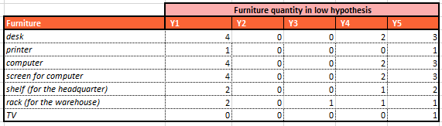

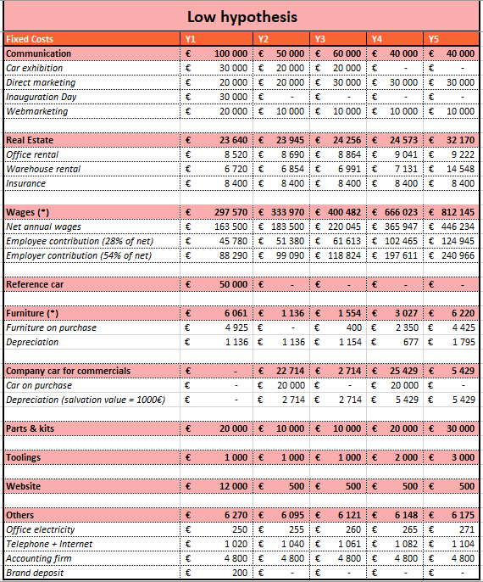

### X.1.2 Variable costs

Variable costs are exactly the same as in the high case.

### X.1.3 Profit and losses

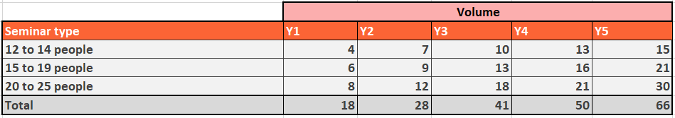

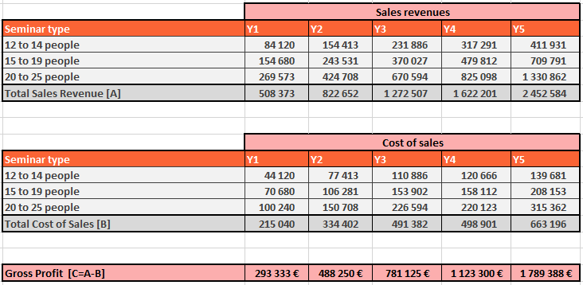

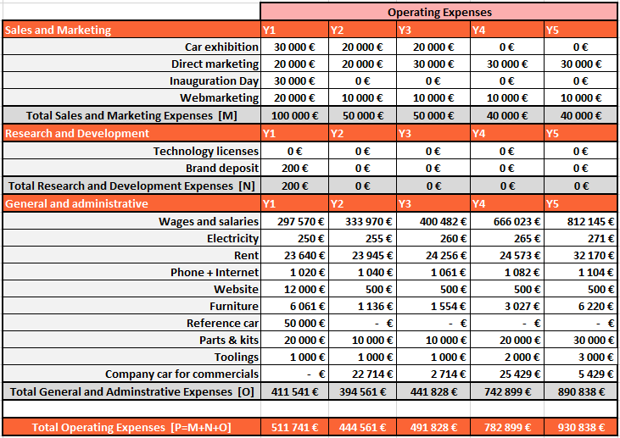

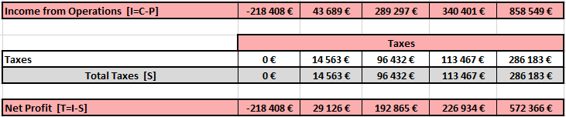

### X.1.4 Fiancial analysis : Input data

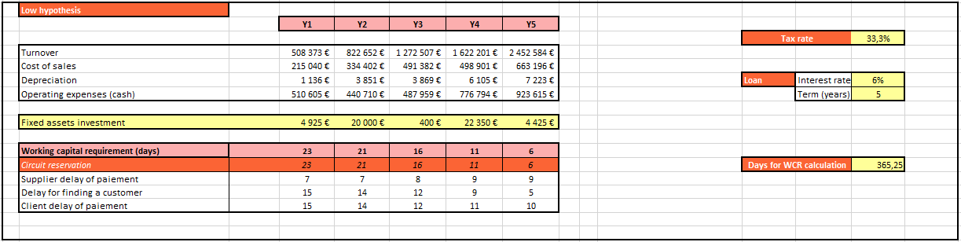

### X.1.5 Statement of income

### X.1.6 Cash flow statement

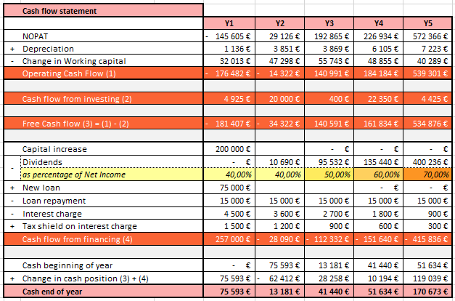

### X.1.7 Balance sheet & indicators

